1. **Generate a transfer function Matlab**

* This laboratory session is intended to demonstrate the principles of gain margins in classical control which can be obtained from Bode diagrams
* Consider the transfer function:



* Use the Matlab tf function to generate this Matlab transfer function for the open loop system and place this in a variable sys.
* If you display the contexts of transfer function variable sys you should get the following output:

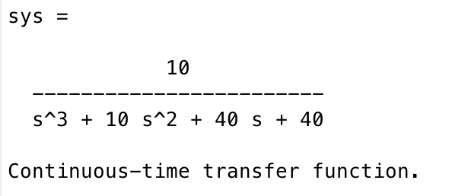

1. **Using initial and final value theorem**

* Use the Laplace initial and final value theorems to calculate:
* The initial response to a step input
* The final response to a step input
* HINT: remember the factor s arising from the theorem and the factor 1/s arising from the step function!
* Show the algebraic steps in your calculation of both of these quantities.

1. **Bode diagram for open loop response**

* Use Matlab to generate a Bode plot of the open loop transfer function.
* You should get a plot that looks something like this:

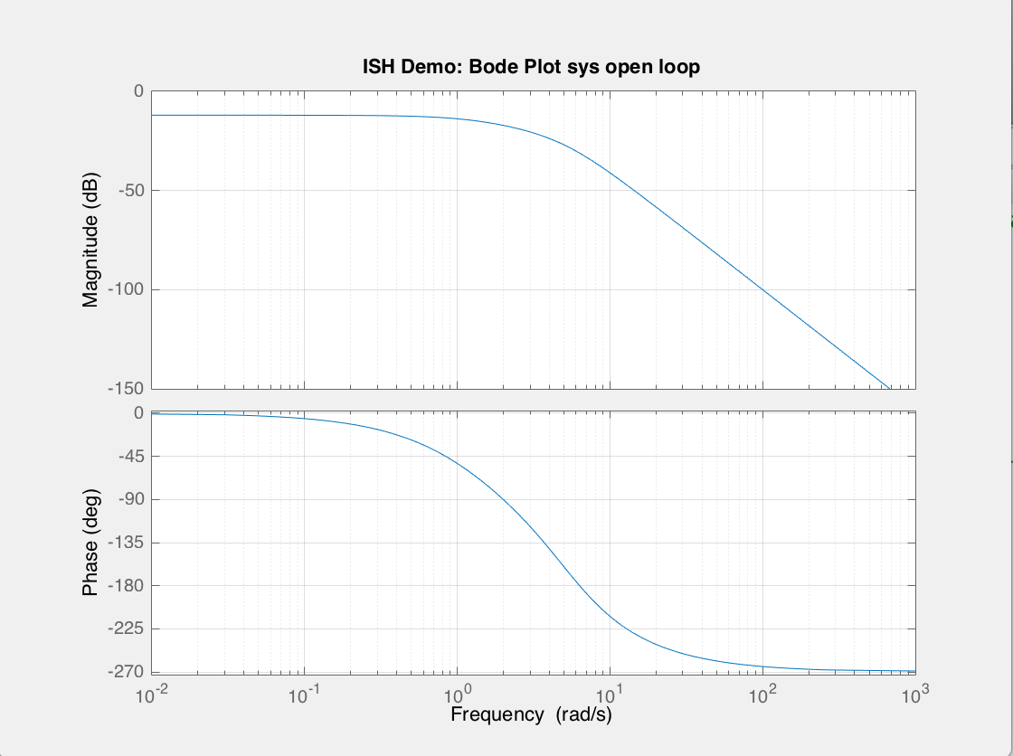

* Estimate the bandwidth of the transfer system from the Bode plot
* HINT: Bandwidth frequency is value corresponding to a gain of -3 dB
* Estimate the system rise time for step input
* What is the significance of the gain and phase margins in conjunction with feedback control?
* Identify the open loop system gain and phase margins on the Bode diagram.

1. **Build open-loop Simulink simulation**

* Implement the transfer function sys in Simulink
* Drive it with a step function
* Display the sys output on a scope
* Also simultaneously display the input step waveform on the scope too
* Your Simulink model should look something like this:

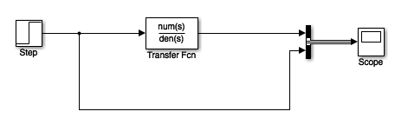

* Put the scope output response into your report.
* Your open-loop Simulink scope output should look something like this:

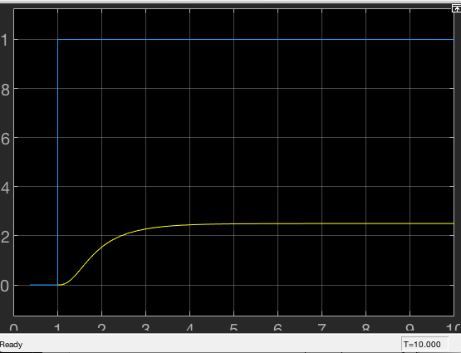

* What characteristics of this response are important?
* Compare your results for the critical measurements of performance with those from the initial and final value theorem predictions and the rise time prediction

1. **Build closed-loop Simulink simulation**

* Now build a closed-loop control system
* Set the feedback path gain to a value of -1 to give negative feedback
* Put an additional gain of 10 in the forward path
* Drive with step function and display output on scope
* Also simultaneously display the input step waveform on the scope too
* Your Simulink model should look something like this:

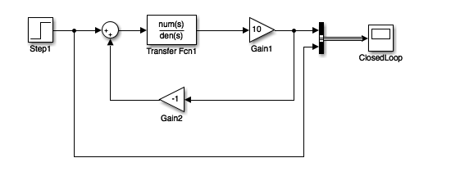

* Put the scope output response into your report.
* Your closed-loop Simulink scope output should look something like this:

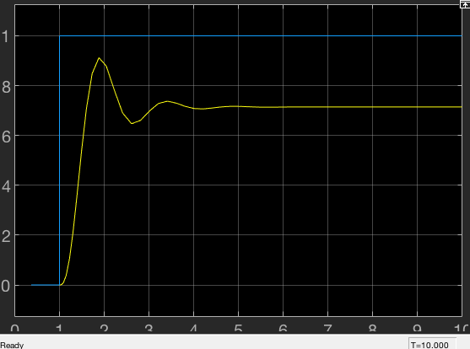

1. **Build closed-loop transfer function**

* Feedback gives rise to a modified transfer function
* HINT: remember for following system:

 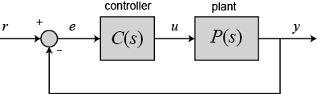



* HINT: In this case C(s) = 10
* Calculate the closed-loop transfer function of your system with the additional gain of 10 in the forward path.
* Directly implement this transfer function in an open-loop simulation using Simulink
* Again drive it by a step waveform and record the scope output
* Show that you get the same response as you did with the feedback system in part 4.

1. **Add gain to close-loop Simulink simulation**

* Using the gain margin you computed earlier, adjust gain of your feedback control system in Matlab so that results in a system that has gain that is:
* Just below the gain margin
* Just above the gain margin
* What gain values did you use?
* Run the step response simulations in Simulink and record the output in both cases.
* You should get results similar to these:
* Just below gain margin:

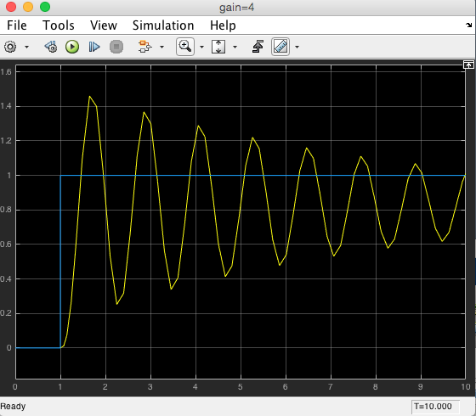

* Just above gain margin:

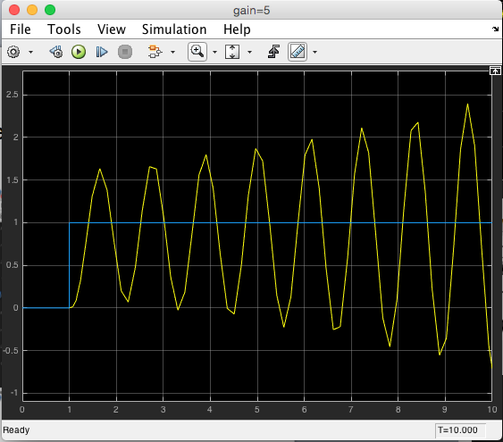

* What can you say about the system outputs in these two gain conditions?
* What characteristics of system output are important if a system is to remain stable?